**Online Gaming Tech Lab 3-**

**Parts 3 -> 7**

3. Draw an IP header:

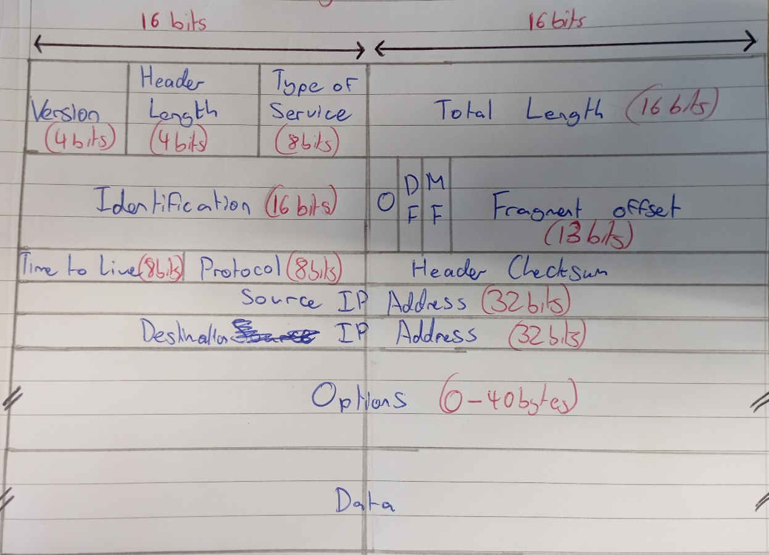

4. Explain the fields for a particular IP packet captured. Try to explain the purpose of each field.

Version:

The first field in the IPv4 header is the version field. It is used to indicate the current version of the Internet Protocol or IP being used.

Header Length:

Header Length represents the number of 32 bit words contained in the header.

Type of Service:

TOS is how the datagram should be used. For example delay, precedence, reliability, minimum cost etc.

Total Length:

Total Length is a 16 bit field indicating the entire sixe of the IP packet (header and data) in bytes. The min size is 20 bytes (no data) and max size is 65.535 bytes

Identification:

When the IP packet is fragmented then every packet will used a common 16 bit ID number to identify the which IP packet it belongs to.

IP Flags:

These are 3 bits used for fragmentation:

* First bit is set to 0
* The second bit is DF (Don’t Fragment), which indicates that this packet should not be fragmented
* The third bit is MF (More Fragments) and is set on all fragmented packets except the final one.

Fragment Offset:

Signifies the position of the fragment in the original fragmented IP Packet.

Time to Live:

When an IP packet passes through a router the ttl field is decremented by 1. When 0 the router will drop the packet and send an ICMP time exceeded message to the sender.

Protocol:

Protocol tells us which protocol is encapsulated in the IP packet. Eg: TCP has a value of 6 and UDP has a value of 17.

Header Checksum:

Used to store a checksum of the header. The receiver can use the checksum to check if there are any errors.

Source Address:

32-bit source IP Address

Destination Address: 32-bit destination IP Address.

IP Option:

Optional field with variable length. Using this will increase header length. Possible option is source route where the sender requests for a certain routing path.

5. Here you find a network trace with fragment bit set in the IP packets. What’s the major difference from the packet you described for answering previous questions.

https://wiki.wireshark.org/SampleCaptures?action=AttachFile&do=get&target=ipv4frags.pcap

6. List three games you like and list their technical/design highlights.

Halo: Ground breaking mechanically for the time. Changed the course of shooters forever.

Mass effect 2: Fantastic character writing and emotional relationships with said characters.

Red dead redemption 2: The most realistic telling of the breakdown of a relationship between multiple people in gaming history. A fantastic telling of a story from start to finish in which you see characters become who they truly are and find themselves on front of your eyes.

7. List the names of applications/services you like (up to 20 names).

YouTube, Revolut, Gamepass, WhatsApp and Reddit.